COMP 10071 Capstone Project

Final Project Report

# Developed By: Chao Zhang

# Student ID: 000306946

Date Submitted: April 15th, 2016

Testing Plan

*Test to Pass*

* Login
  + Proper login credentials



* + Login redirect



* + Logout redirect



* Registration
  + Proper data entry

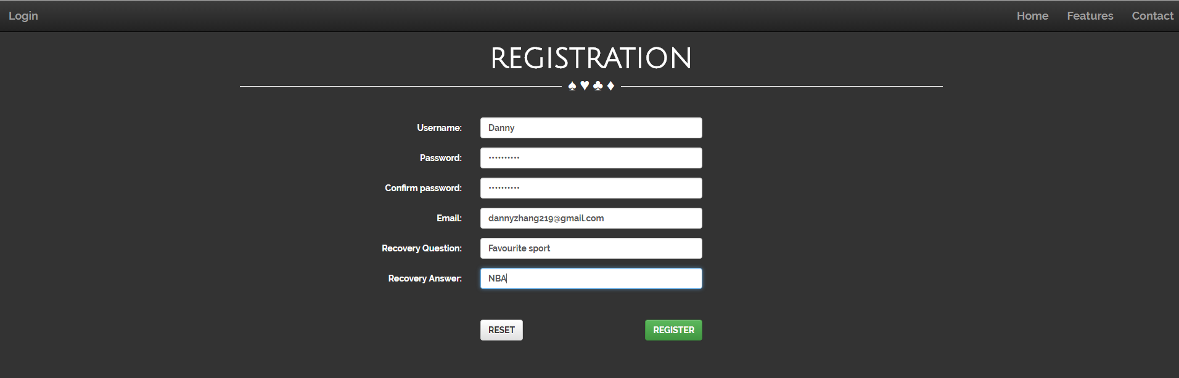

* + Confirmation Email





* + Registration Redirect



* How to Play
  + Embedded videos playing



* User Management page
  + Proper data entry

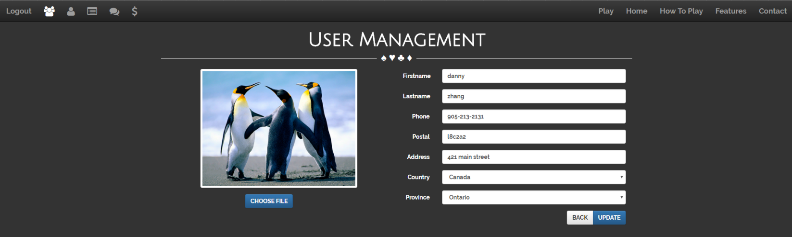

* Requests
  + Amount request added to user credit

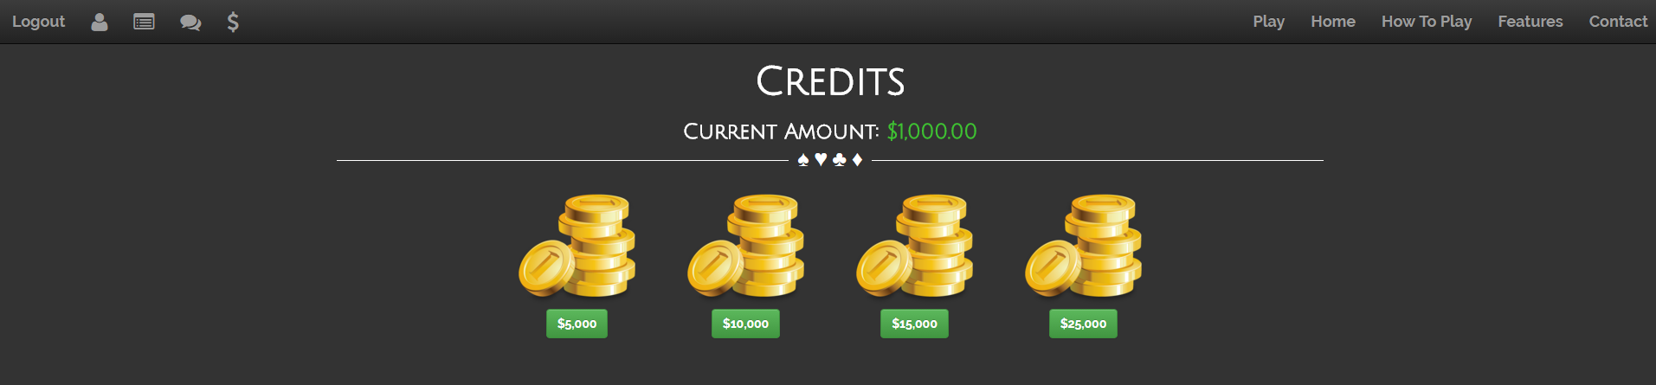

* + Request approval by admin

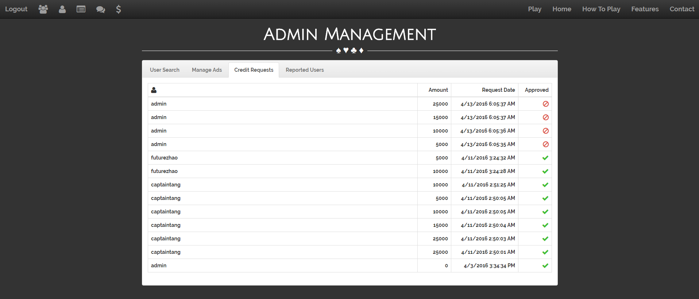

* Game page
  + Correct game logic/winning condition





* + Proper bet amount

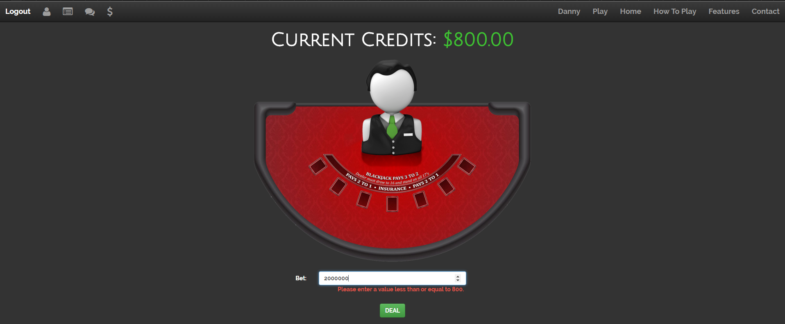

* Admin
  + User search showing results unless no user registered

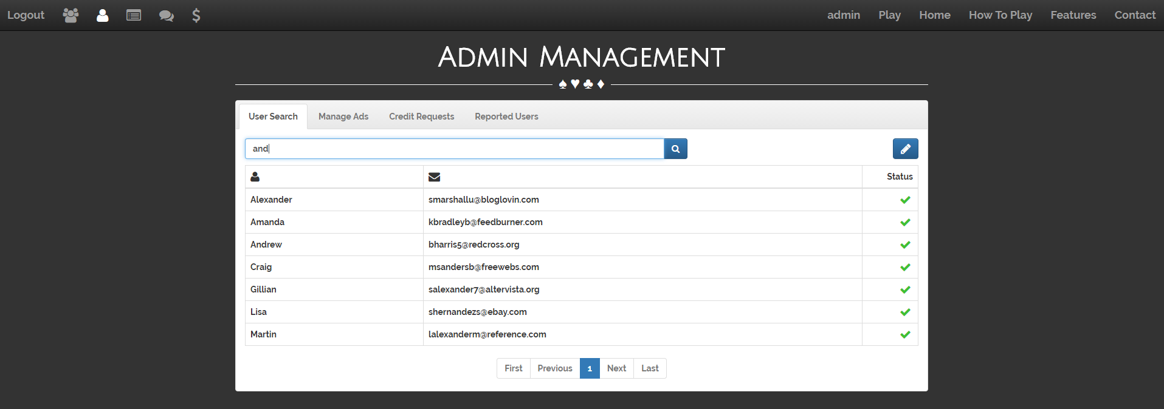

* + User edit proper data entry

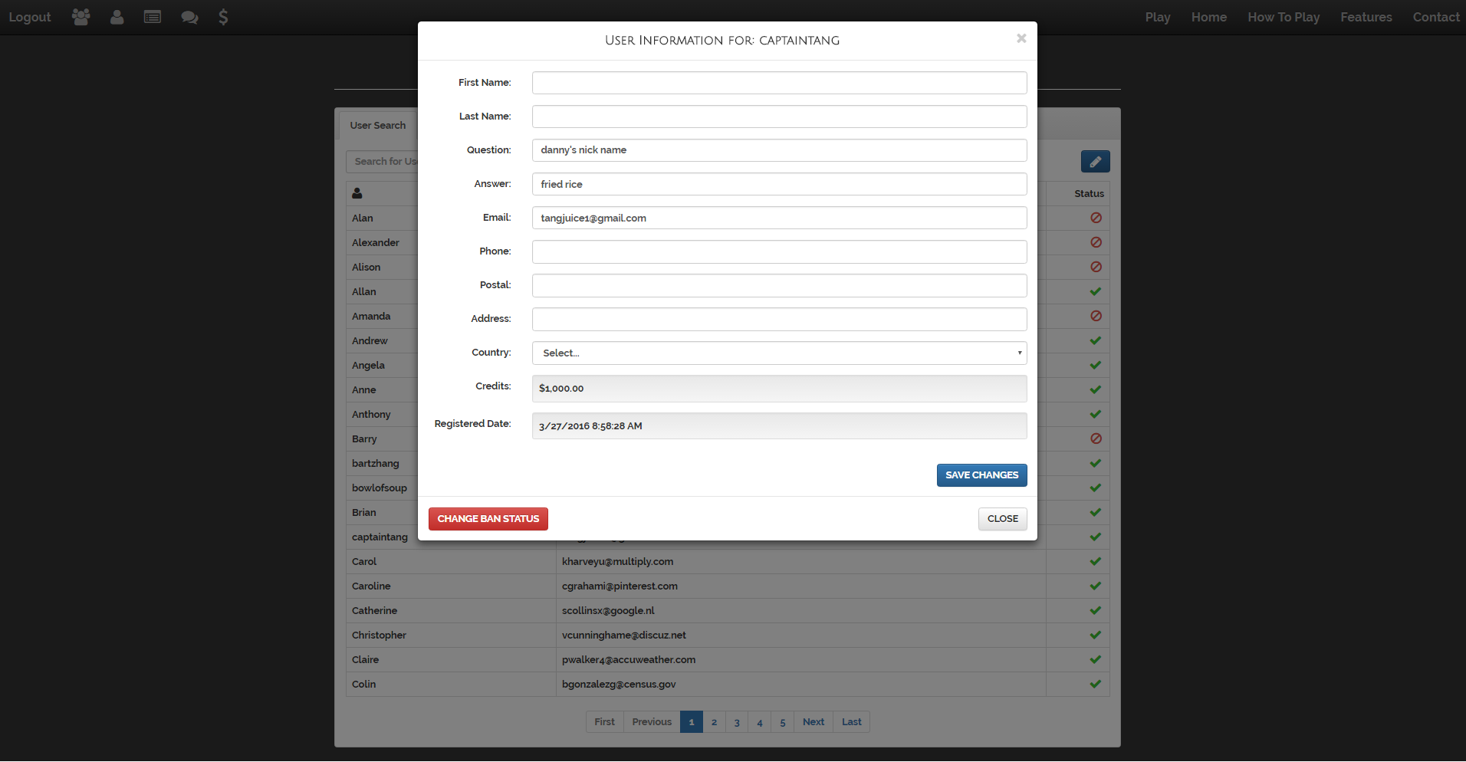

* + User status change

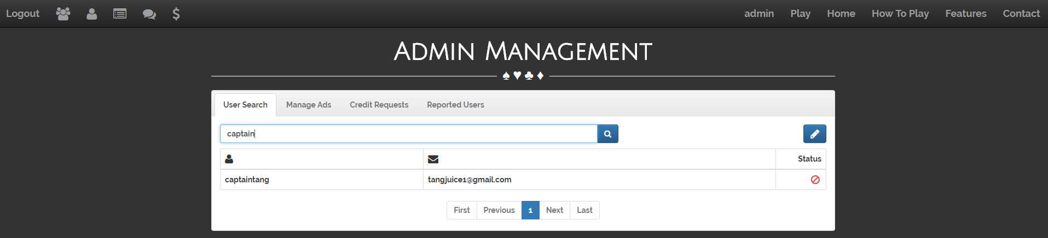



* + Ad management, create

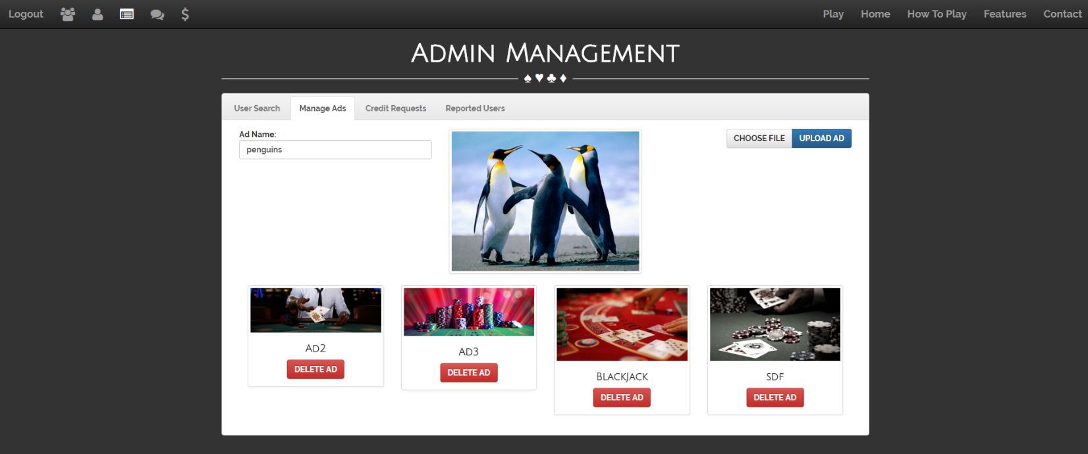

* Discussions
  + New Thread

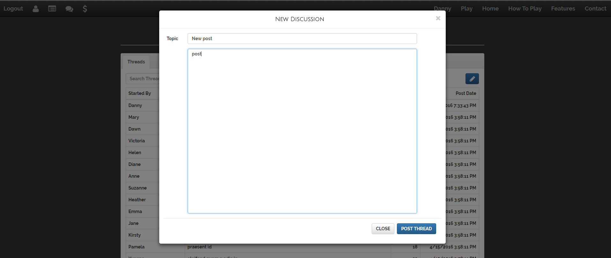

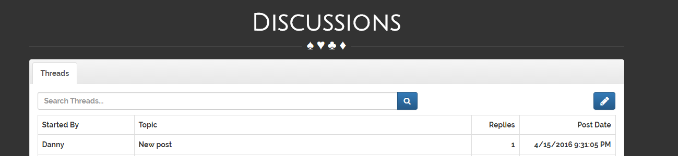

* + New Post

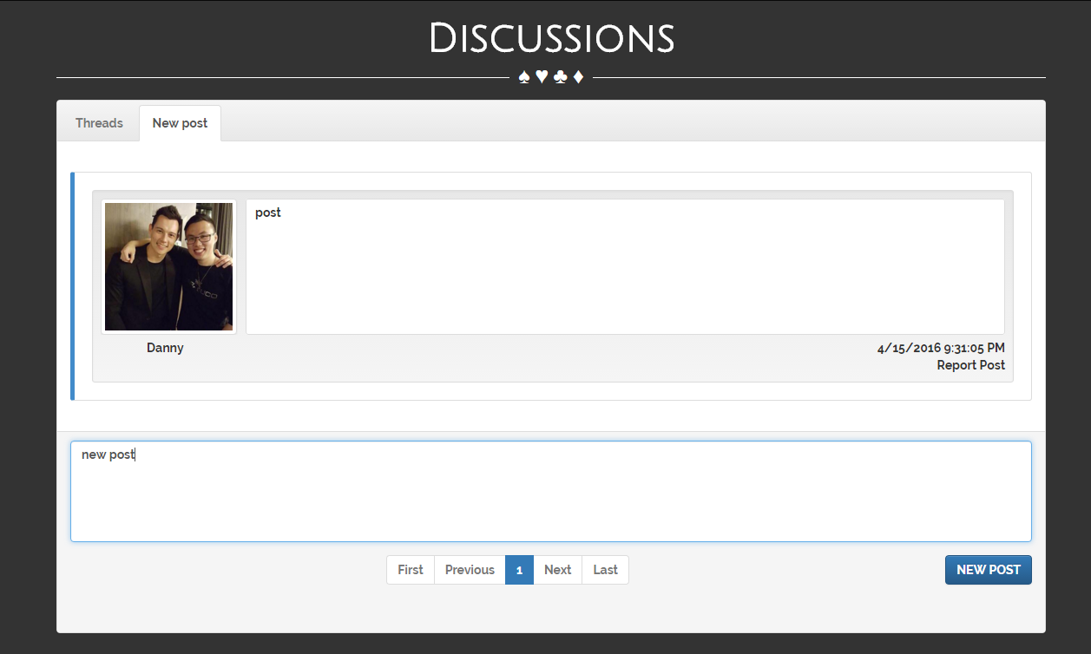

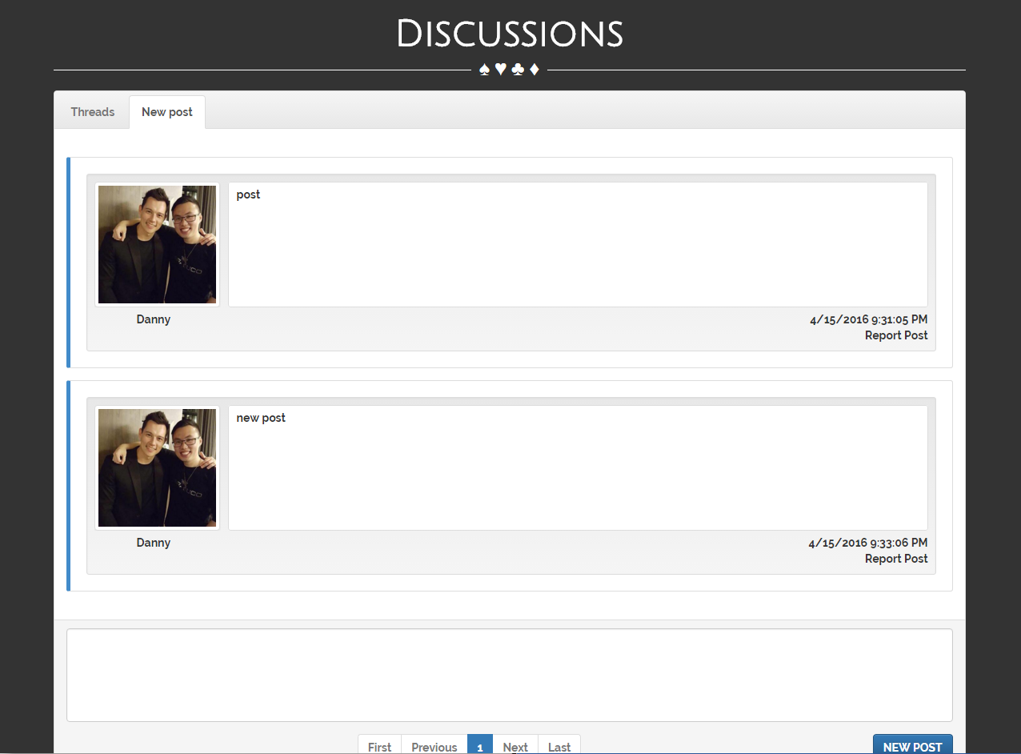

* + Reported Posts

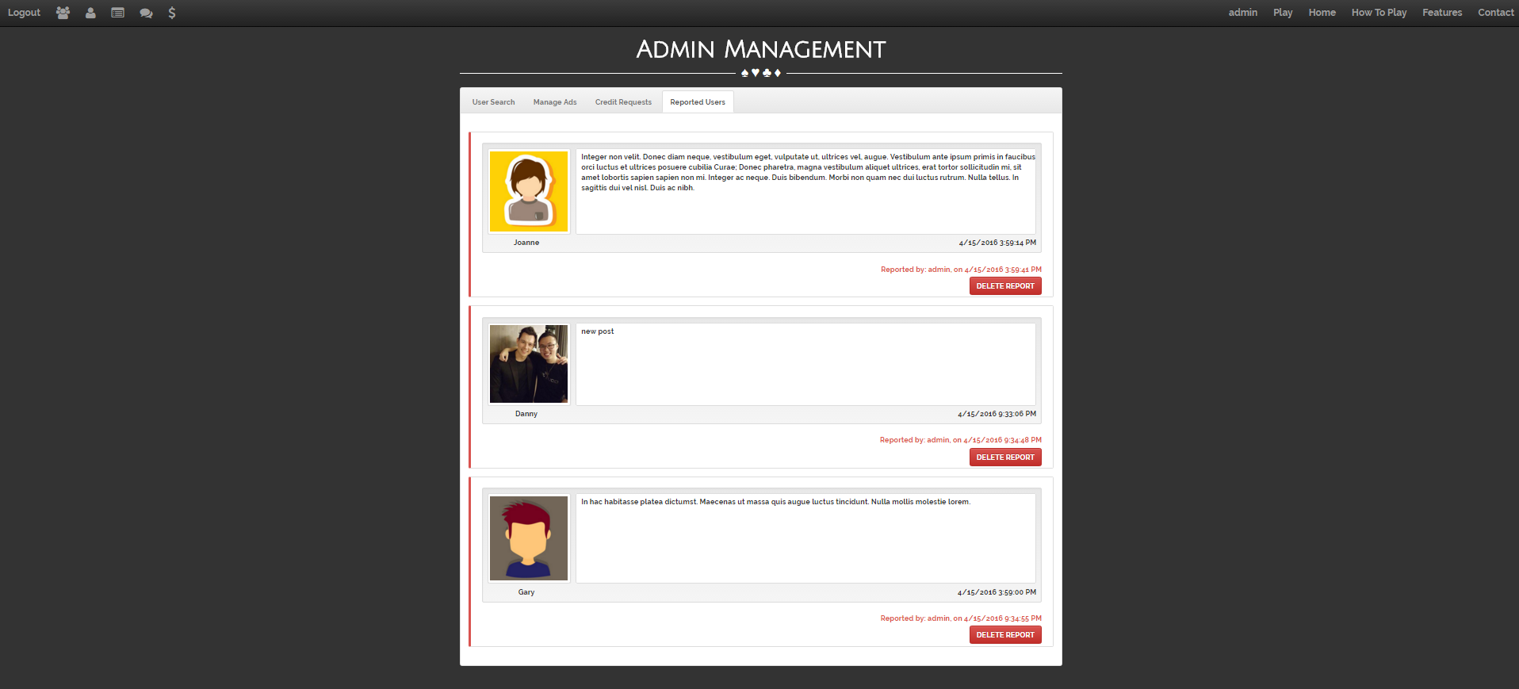

* Password Recovery
  + Proper data entry







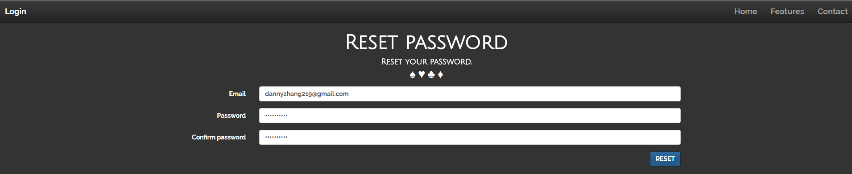



*Test to Fail*

* Improper data entry on all forms that have validation

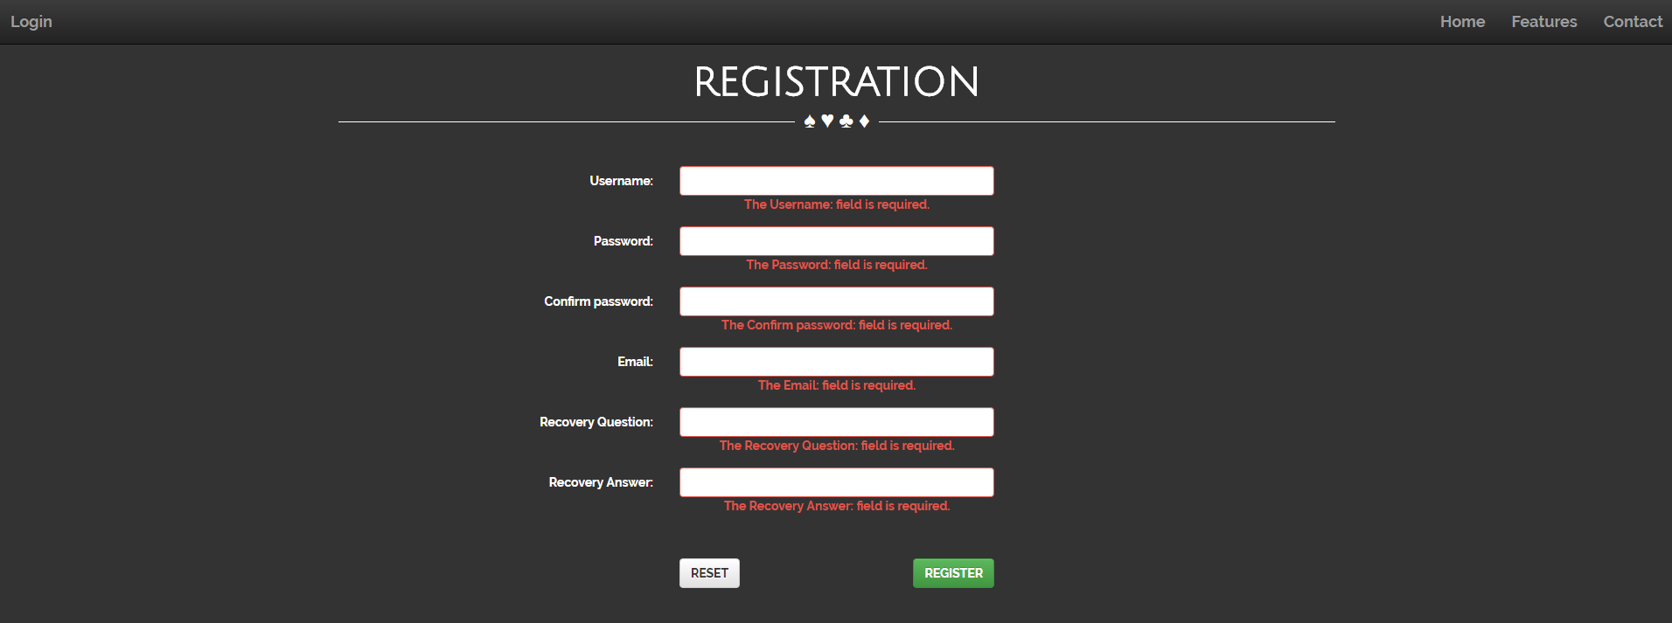

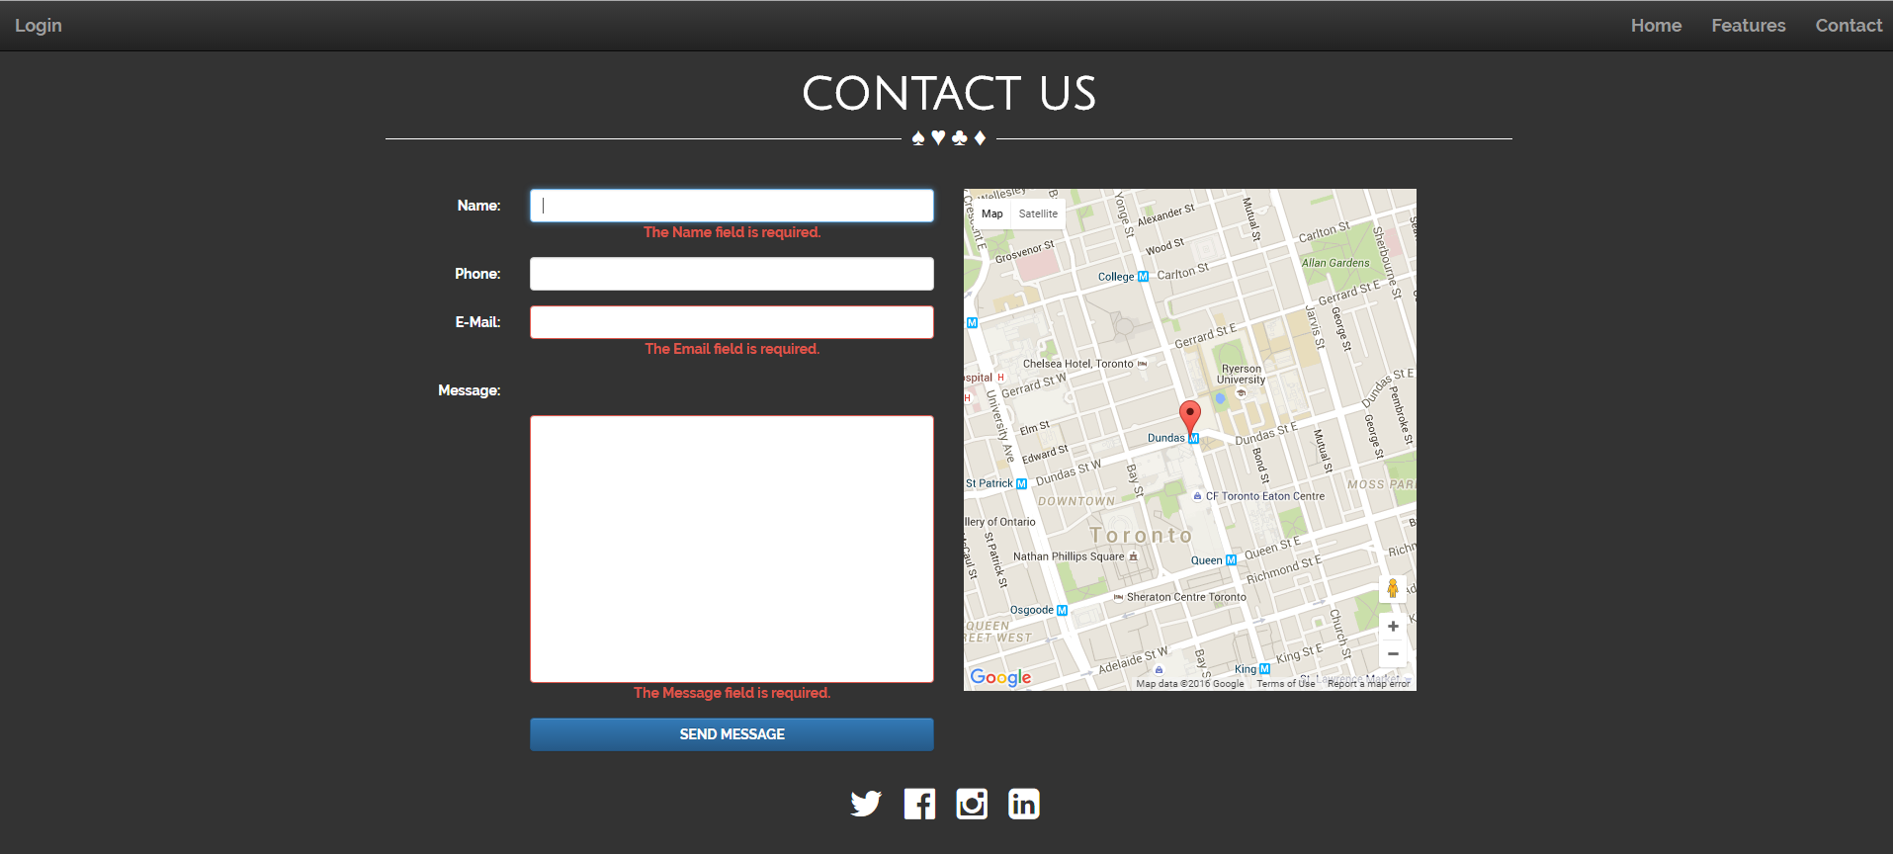

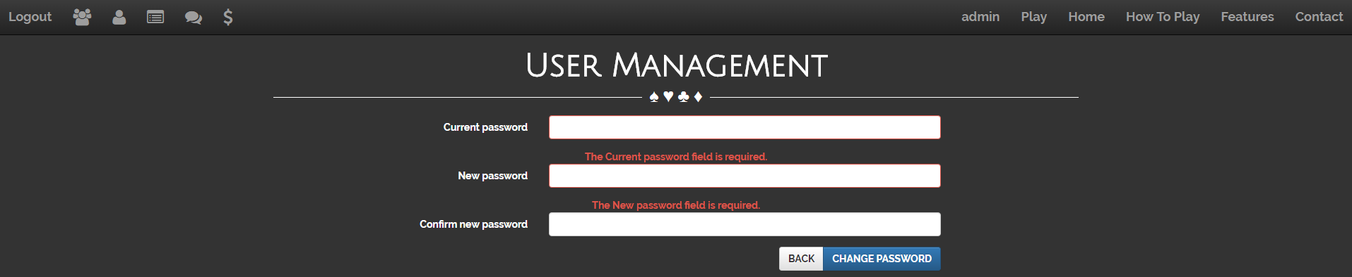

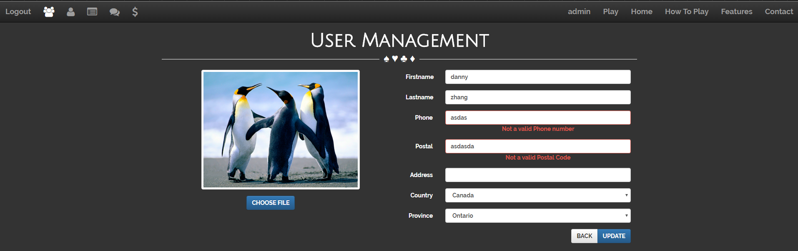

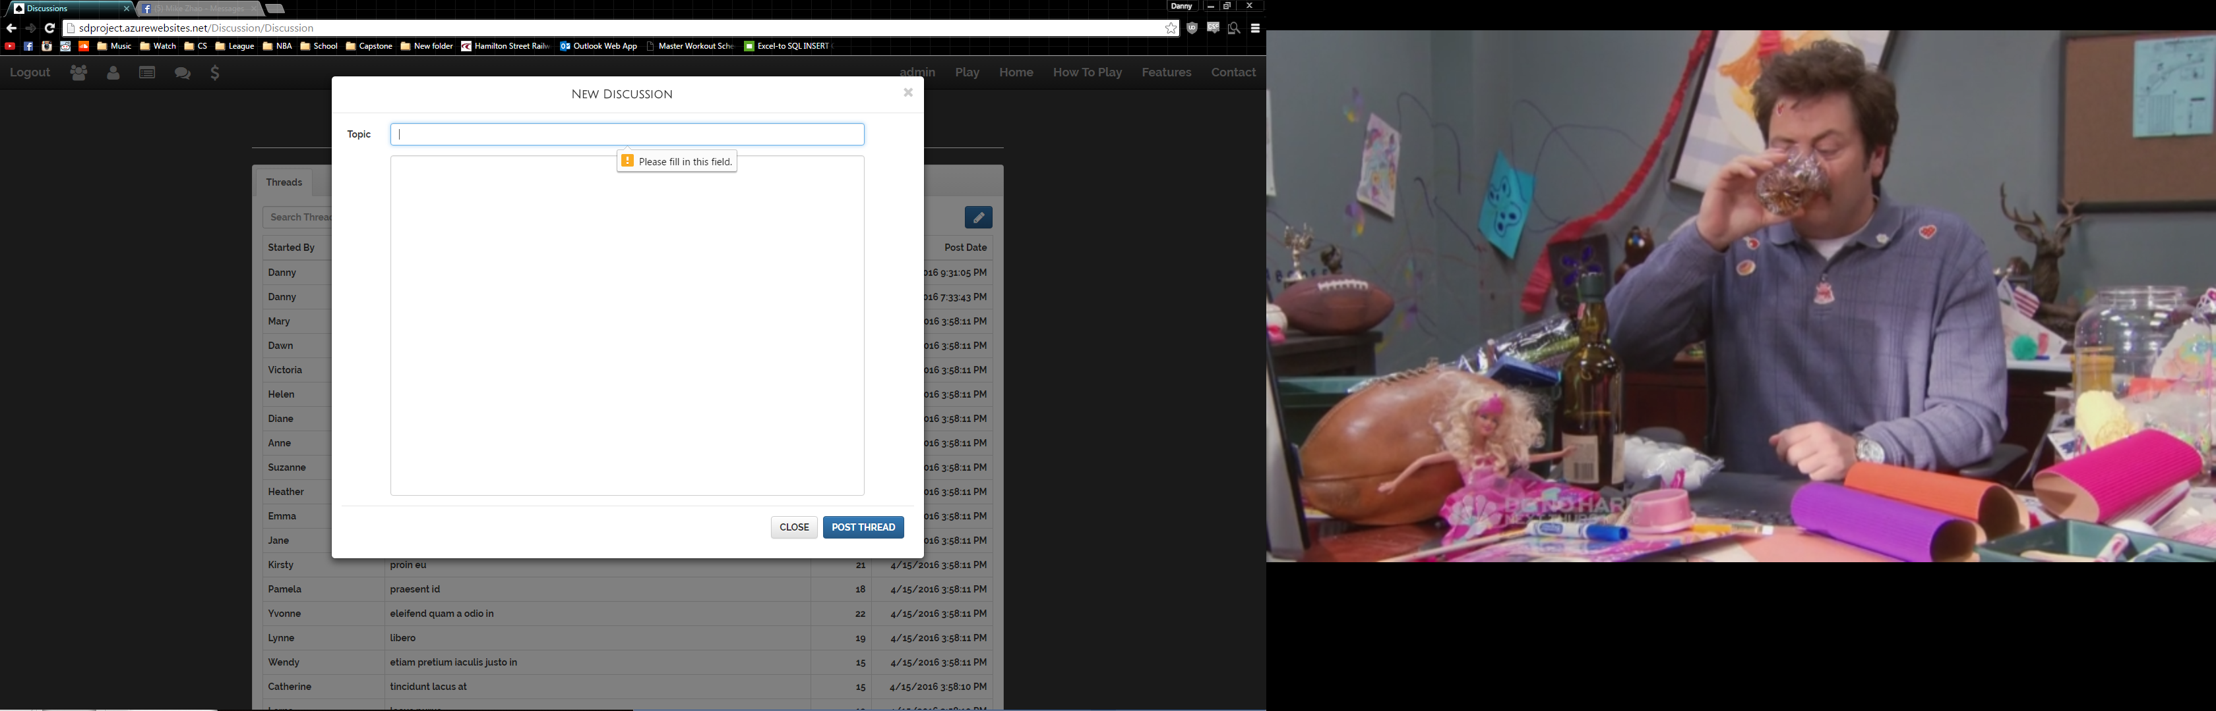

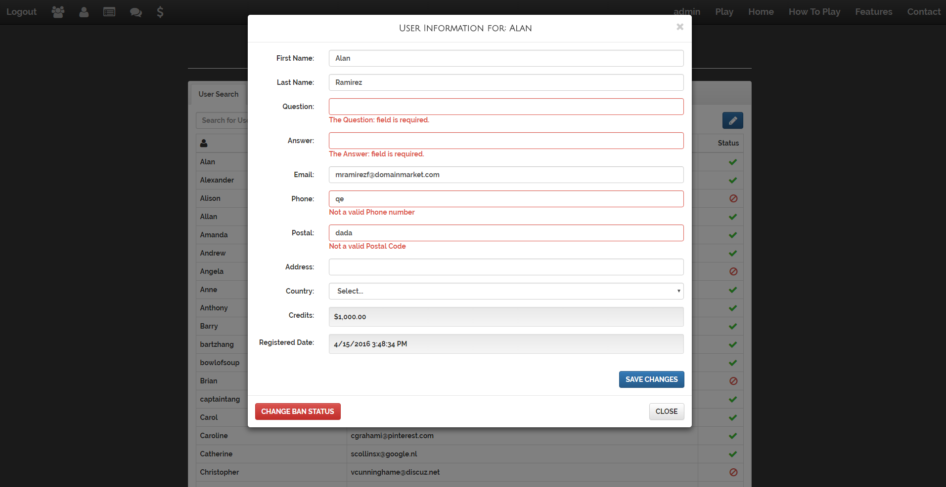

* Creating existing user/using existing e-mail to register

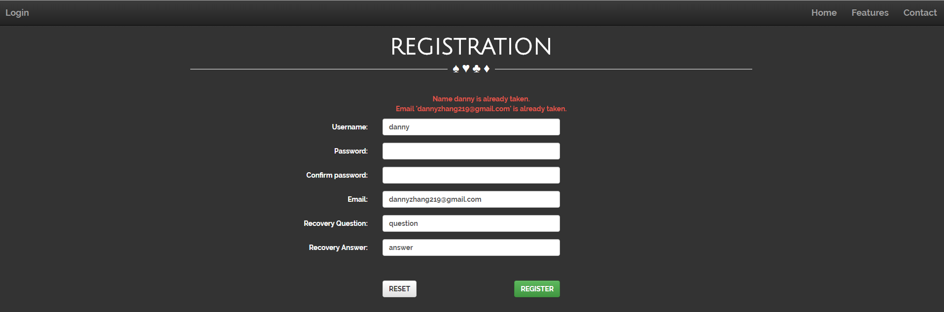

* Improper page navigation based on restriction level
  + anonymous user trying to access admin page, and home page









